**TASK -03**

Security Policies and ACLs

ACLs are rules applied on routers or switches to control the flow of network traffic based on IP addresses, ports, or protocols.

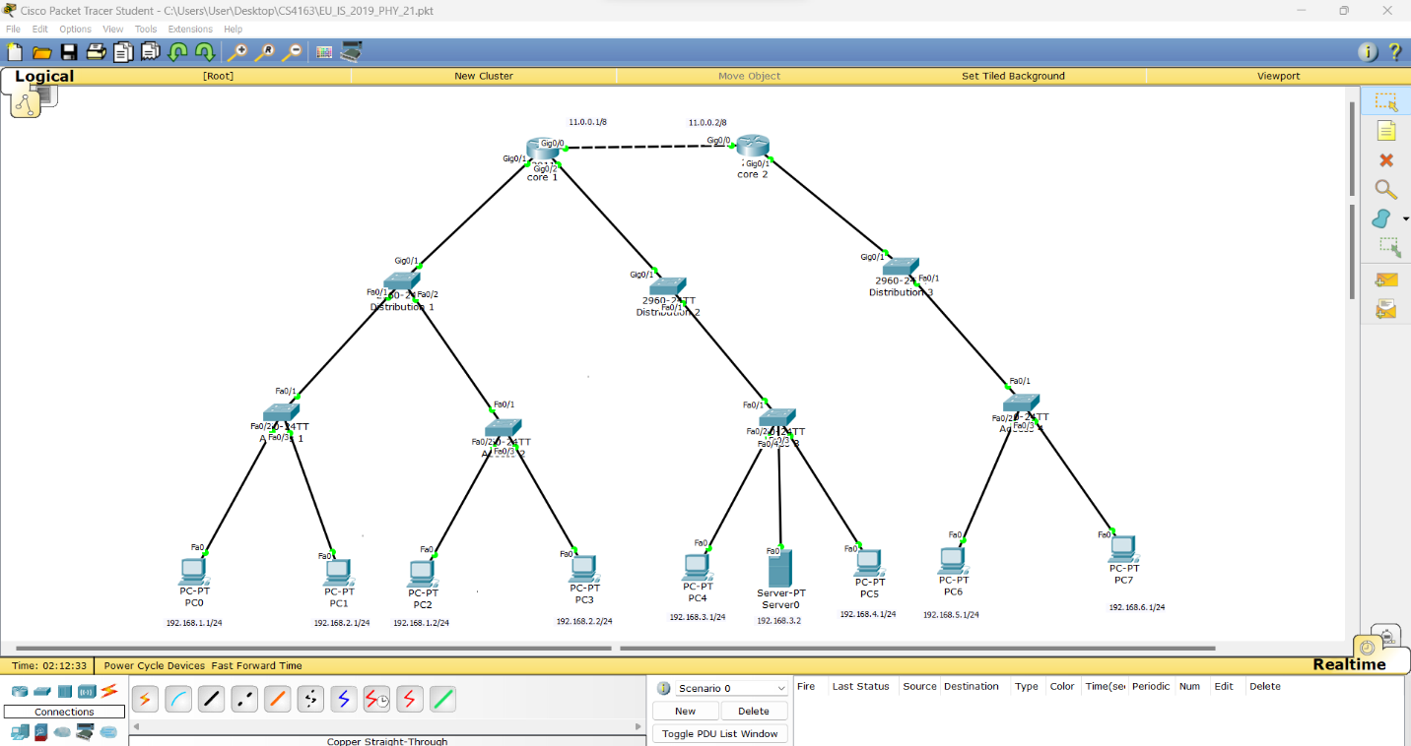

|  |  |
| --- | --- |
| Source vlan subnet | Destination vlan subnet |
| 192.168.1.1  (Management) | 192.168.3.2  (Account) |

Before Block the Server

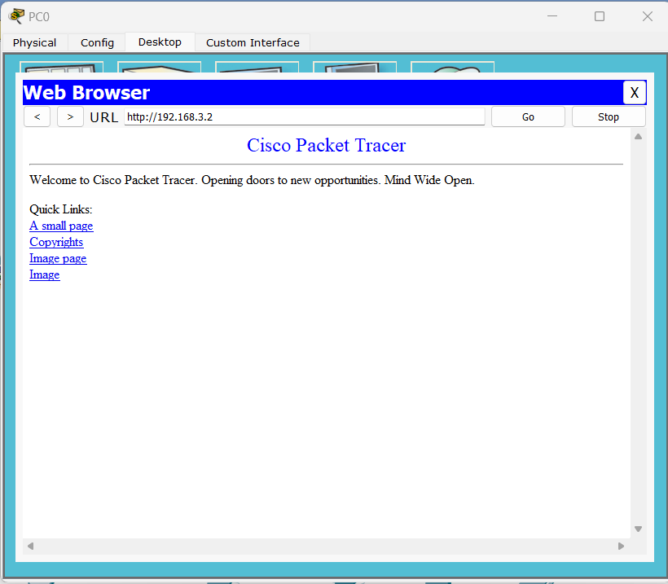

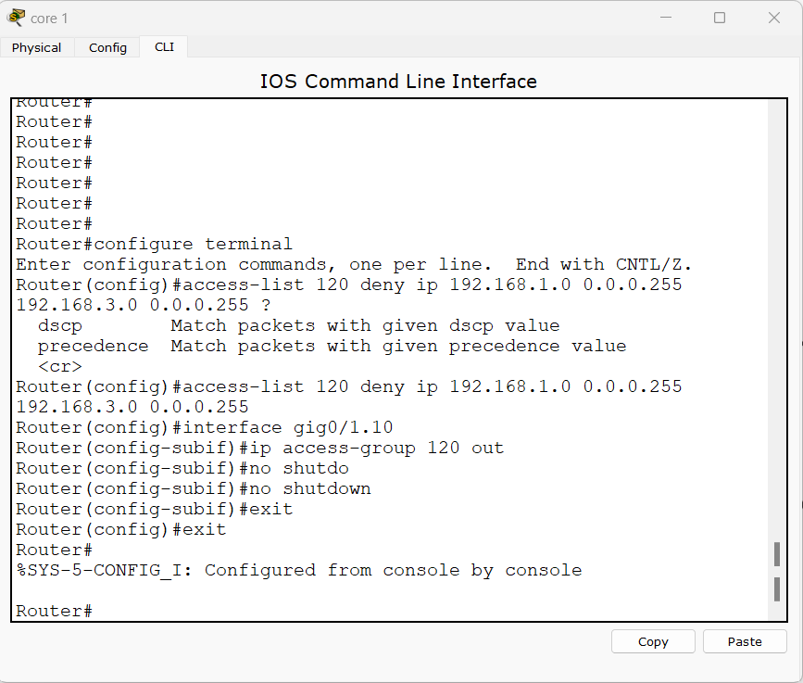

After Block the Server

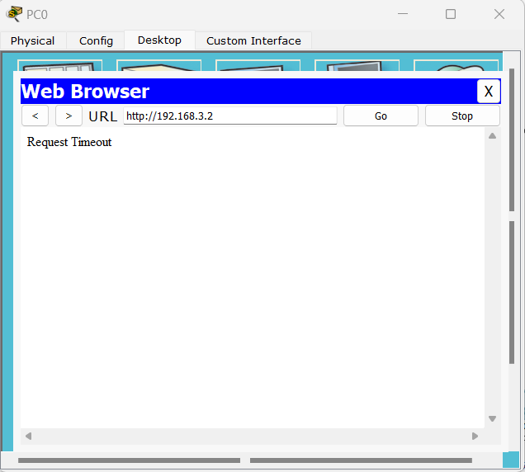

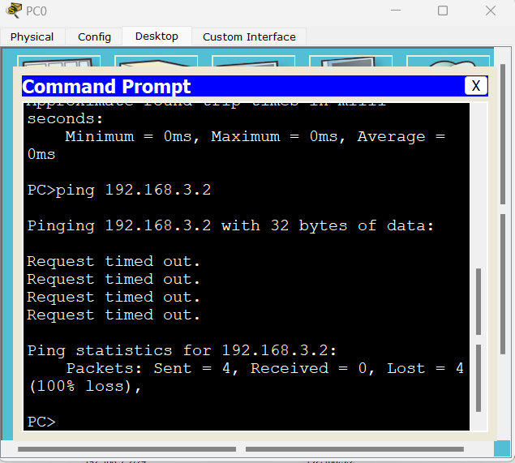

Index Number: PS2771

Registration Number: EU/IS/2019/PHY/21